This Project is implemented in Java using Eclipse IDE.

**Instruction for readme to run file application are as follows:**

From Eclipse:

1) Extract the compressed folder downloaded from eLearning.

2) Import the folder SXB180124DavisBase into the Eclipse IDE.

3) Left Click on DavisBase and Select Run as Java Application OR Run the DavisBase.java to start the application.

(or)

From local terminal:

4) Extract the compressed folder SXB180124DavisBase

5) Open terminal or command prompt

6) Navigate to the path where the folder has been extracted.

7) Change directory to the SXB180124DavisBase\src\ in terminal and compile all files using the below command:

javac *.java

8) Change directory to parent directory (SXB180124DavisBase\src)

9) Run DavisBase.java file using the below command:

java DavisBase

**Following are the commands supported by DavisBase:**

**DDL Commands:**

**a) SHOW TABLES:** To Display a list of all tables in DavisBase.

**Syntax:** SHOW TABLES;

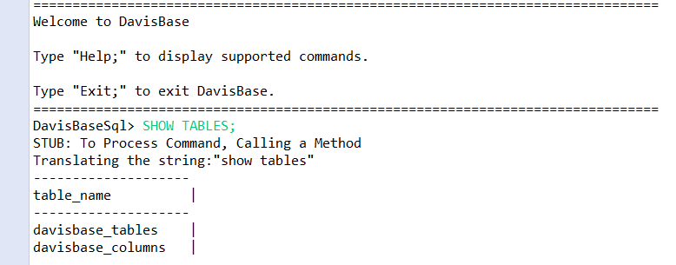

**b) CREATE TABLE:** Creates a new table schema, i.e. a new empty table.

**Syntax:** CREATE TABLE <table_name> (<column name> <constraint>, ...);

**c) DROP TABLE:** Remove a table schema, and all its contained data.

**Syntax:** DROP TABLE <table_name>;

**DML Commands:**

**INSERT INTO:** Inserts a single record into a table.

**Syntax:** INSERT INTO table_name <column_list> VALUES <value_list>;

**Note1:** Here the Value for the Column can be skipped as it can be generated dynamically with use of auto increment feature implemented on Primary Key.

**Note2:** If the duplicate value is passed for column, then it throws an error

“Duplicate Key for column_name is found”.

**Note3:** If a null value is passed in NOT NULL value column, then it throws error

“There is a NULL-value constraint violation”.

**VDL Command:**

**a) SELECT-FROM-WHERE:** style query

**Syntax:** SELECT * FROM <table_name>;

**Syntax:** SELECT * FROM <table_name> [WHERE <condition>];

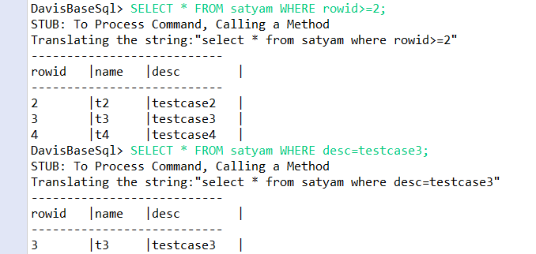

**Note:** When NULL is used in where condition, the database engine equate null value in data with the where condition.

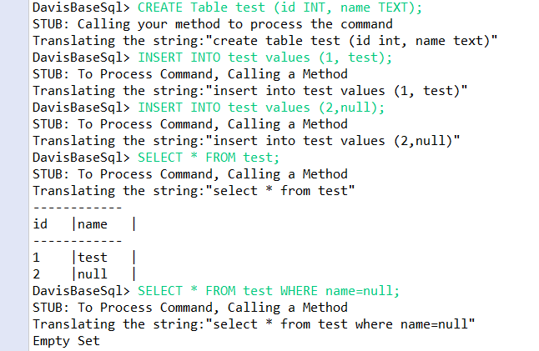

**b) Exit:** Cleanly exits the program and saves all table information in non-volatile files.

**Syntax:** exit;

